Business Report

Health Care Capstone Project
By
Rajesh Mambulli

Business Problem
We all know that Health care is very important domain in the market. It is directly linked with the life of the individual; hence we must be always be proactive in this domain. Money plays a major role in this domain, because sometime treatment becomes super costly and if any individual is not covered under the insurance, then it will become a tough financial situation for that individual. The companies in the medical insurance also want to reduce their risk by optimizing the insurance cost, because we all know a healthy body is in the hand of the individual only. If individual eat healthy and do proper exercise the chance of getting ill is drastically reduced.

Goal & Objective
The objective of this exercise is to build a model, using data that provide the optimum insurance cost for an individual. You must use the health and habit related parameters for the estimated cost of insurance

Data Dictionary
- applicant_id: Applicant unique ID
- years_of_insurance_with_us: Since how many years customer is taking policy from the same company only
- regular_checkup_lasy_year: Number of times customers has done the regular health check-up in last one year
- adventure_sports: Customer is involved with adventure sports like climbing, diving etc.
- Occupation: Occupation of the customer
- visited_doctor_last_1_year: Number of times customer has visited doctor in last one year
- Cholesterol_level: Cholesterol level of the customers while applying for insurance
- daily_avg_steps: Average daily steps walked by customers
- age: Age of the customer
- heart_decs_history: Any past heart diseases
- other_major_decs_history: Any past major diseases apart from heart like any operation
- Gender: Gender of the customer
- avg_glucose_level: Average glucose level of the customer while applying the insurance
- bmi: BMI of the customer while applying the insurance
- smoking_status: Smoking status of the customer
- Year_last_admitted: When customer have been admitted in the hospital last time
- Location: Location of the hospital
- weight: Weight of the customer
- covered_by_any_other_company: Customer is covered from any other insurance company
- Alcohol: Alcohol consumption status of the customer
- exercise: Regular exercise status of the customer
- weight_change_in_last_one_year: How much variation has been seen in the weight of the customer in last year
- fat_percentage: Fat percentage of the customer while applying the insurance
- insurance_cost: Total Insurance cost

Data Overview through Python
Data which is stored in csv file is imported to Jupyter Notebook with the help of pandas, NumPy libraries and used matplotlib and seaborn libraries to help with data visualization. Dataset is stored in python variable named data.
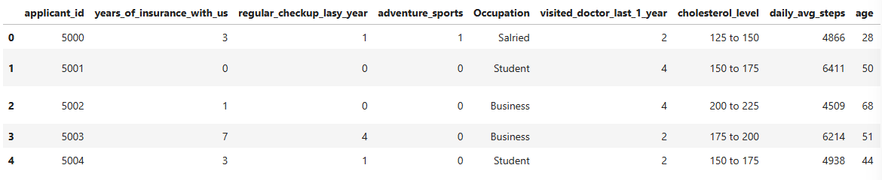
Figure 1: Data Head
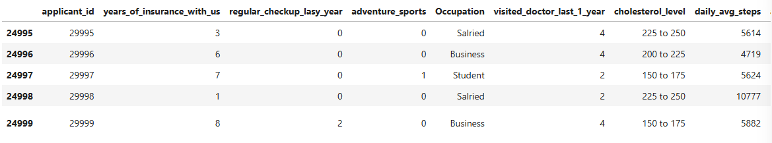
Figure 2: Data Tail
The dataset has 25000 rows and 24 columns.
Checking the data types of data.
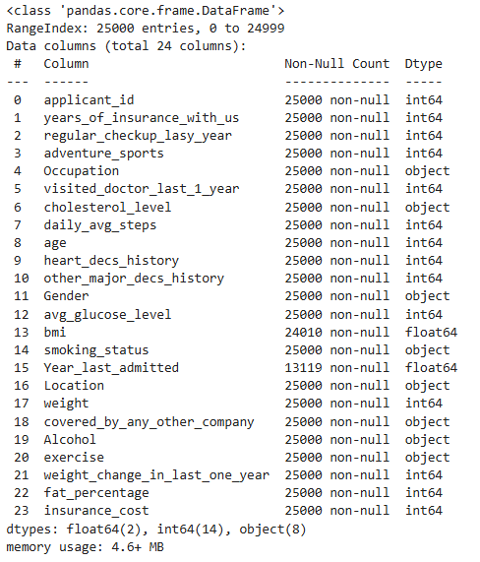
Figure 3: Data Types

Checking for missing values in the data.
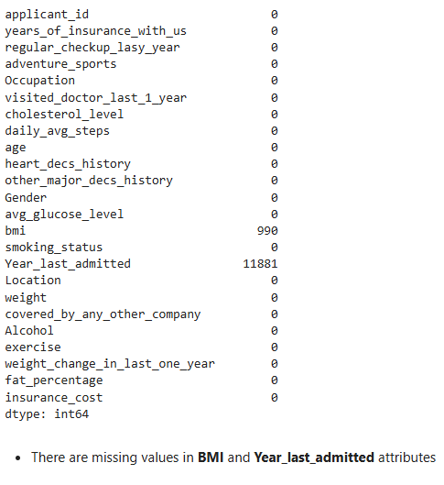
Figure 4: Missing data

Checking for duplicate values in the data.
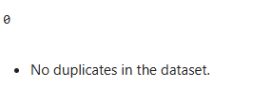
Dropping applicant_id attribute as it doesnot contribute any value to in Data understanding stage

Checking the statistical summary of the data.
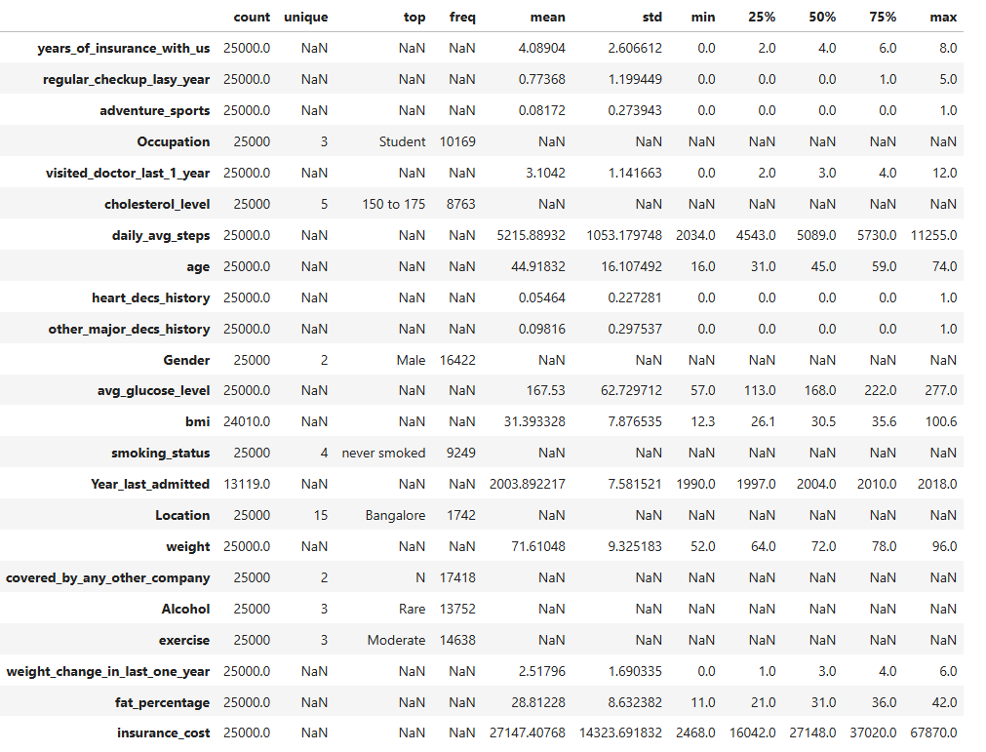
Figure 5: Statistical Data summary
Observations:
years_of_insurance_with_us: Mean ~4 years. Indicates moderate loyalty. Longer duration means more loyalty
regular_checkup_lasy_year: Mean ~1.9 checkups. Reflects moderate proactive care; higher values may indicate stronger health engagement.
visited_doctor_last_1_year: Avg ~3.1 visits. Signals potential existing health concerns or better monitoring.
Cholesterol_level: Most frequent range: 150–175 mg/dL. Mid-range.
daily_avg_steps: Mean ~5,216. Moderately active.
age: Mean ~45 years.
Gender: Male majority.
avg_glucose_level: Mean ~168. High average—potential risk indicator for diabetes, affects premium calculation.
bmi: Mean ~31.4.
smoking_status: Dominated by “never smoked”.
Location: Could reflect regional cost variation.
weight: Mean ~84 kg.
covered_by_any_other_company: Mostly “No”
Alcohol: “Rare” is dominant. Low-risk group; could adjust pricing minimally based on category.
exercise: “Moderate” dominates. Positive lifestyle indicator—linked to reduced claims risk.
weight_change_in_last_one_year: Avg ~2.9 kg. Could indicate lifestyle change, recovery, or instability.
fat_percentage: Mean ~28.8%. Higher fat% aligns with elevated BMI—signals cardio-metabolic risk.
insurance_cost: Mean ~₹27,147.

5.0 Missing Value Imputation
BMI
Imputing Mean value for the Group of Gender, Exercise, Age
Year_last_admitted
The idea behind Year Last Admitted is to define what counts as a recent hosipital admission.
Engineering this feature to Recent Admission would Flag admissions within certain Range like 2 or 3 years as clinically relavant.
But, that again depends on assumption that missing values in this feature as never admitted which inturn makes this feature very synthetic.
Dropping this feature makes more sense.

Missing values after Imputation
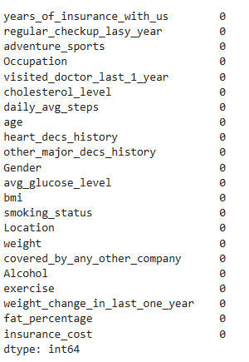
Figure 6: Missing data after imputation

Checking for Outliers
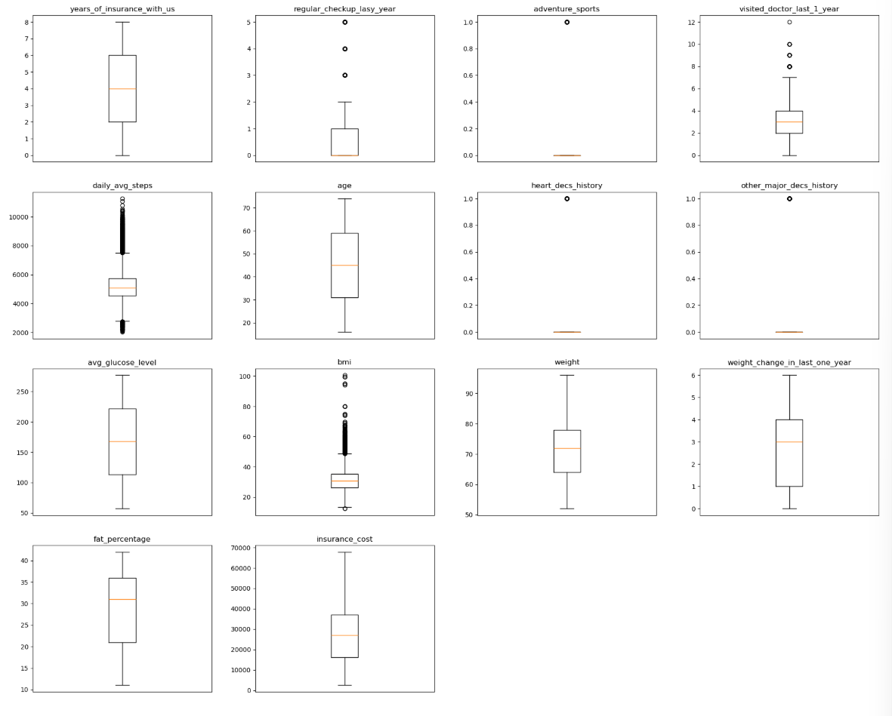
Figure 7: Outliers in data
All are real data not treating any outliers

Exploratory Data Analysis

Univariate Analysis
years_of_insurance_with_us
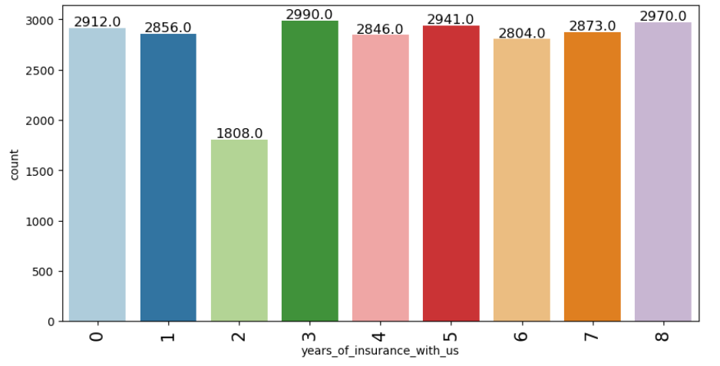
Figure 8: years_of_insurance_with_us
Observations:
- Peak at 3 Years: Highest concentration is at 3 years (2,990 customers)

regular_checkup_lasy_year
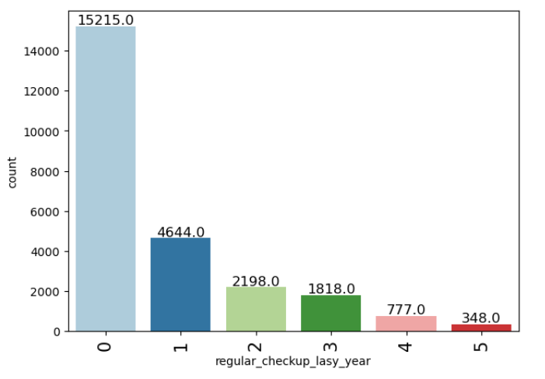
Figure 9: regular_checkup_lasy_year
Observations:
- Most customers do not engage in regular checkups.
adventure_sports
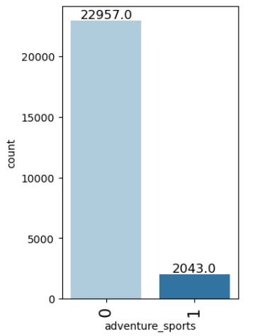
Figure 10: adventure_sports
Observations:
- Most customers do not engage in adventures sports.

Occupation
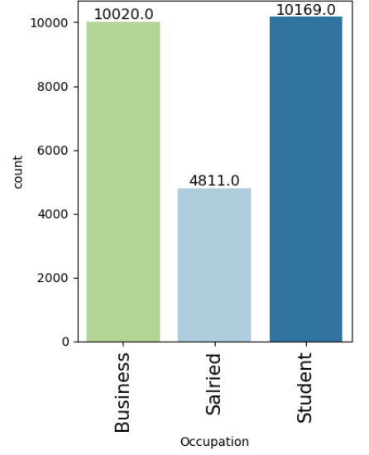
Figure 11: Occupation
Observations: Most of the data belongs to Business and Student occupation
visited_doctor_last_1_year
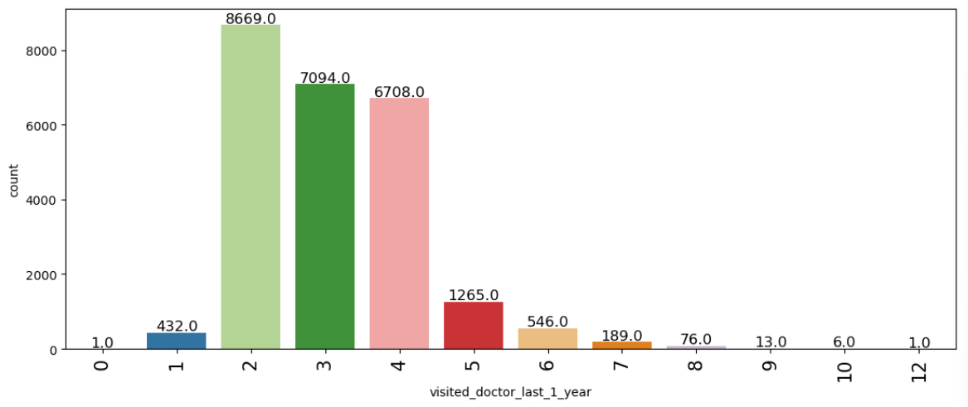
Figure 12: visited_doctor_last_1_year
Observations:
- Most customers visited 2,3.4 times last year
cholesterol_level
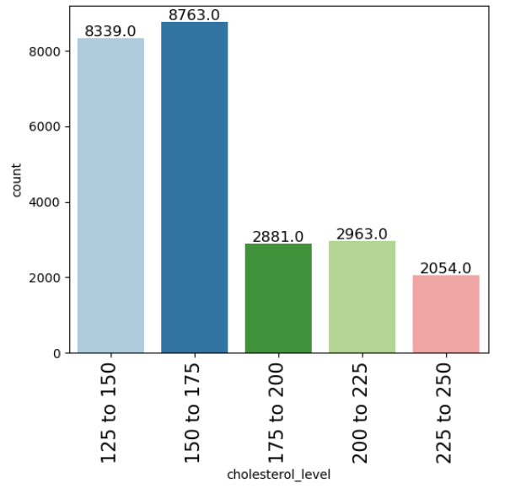
Figure 13: cholesterol_level
Observations:
- Majority of individuals fall within 125–175 range — relatively safe zone. Encouraging from a population health perspective.

daily_avg_steps
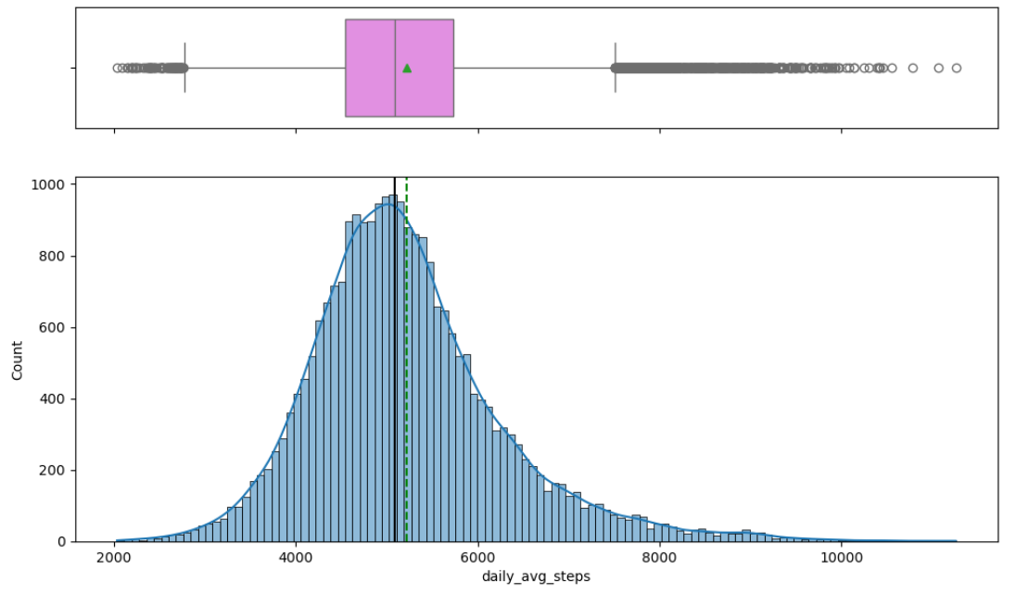
Figure 14: daily_avg_steps
Observations:
- Most customers log between 4,000–6,000 steps daily, creating a dense peak around that zone.
- There is a long tail extending beyond 8,000 steps, but with much lower frequency—very few ultra-active users.
Age
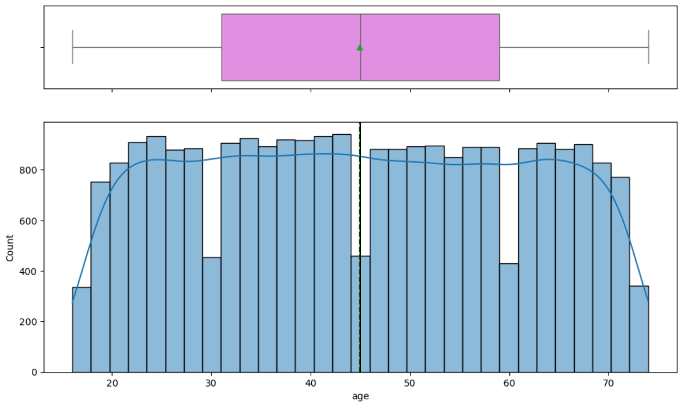
Figure 15: Age
Observations:
- Median Age: Hovering around 45 years.
- Mostly uniform across 20–70
heart_decs_history
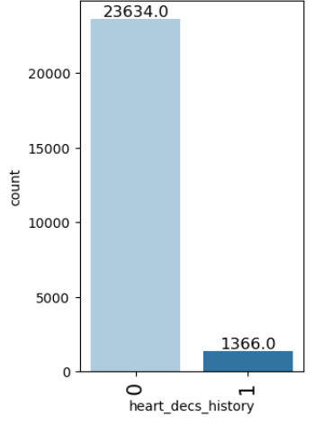
Figure 16: heart_decs_history
Observations:
- Majority of customers have no prior heart conditions

other_major_decs_history
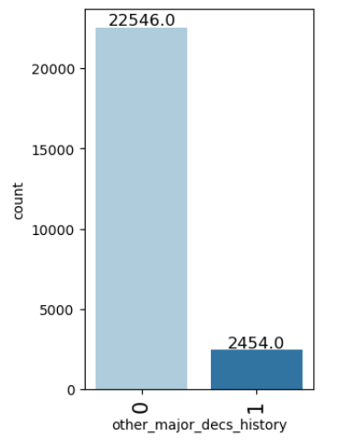
Figure 17: other_major_decs_history

Observations:
- Majority have no record of other major diseases

Gender
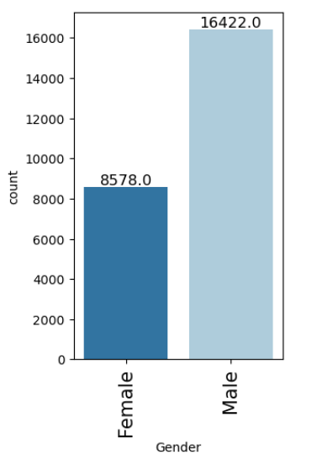
Figure 18: Gender
Observations:
- Male group are Dominant in this dataset
avg_glucose_level
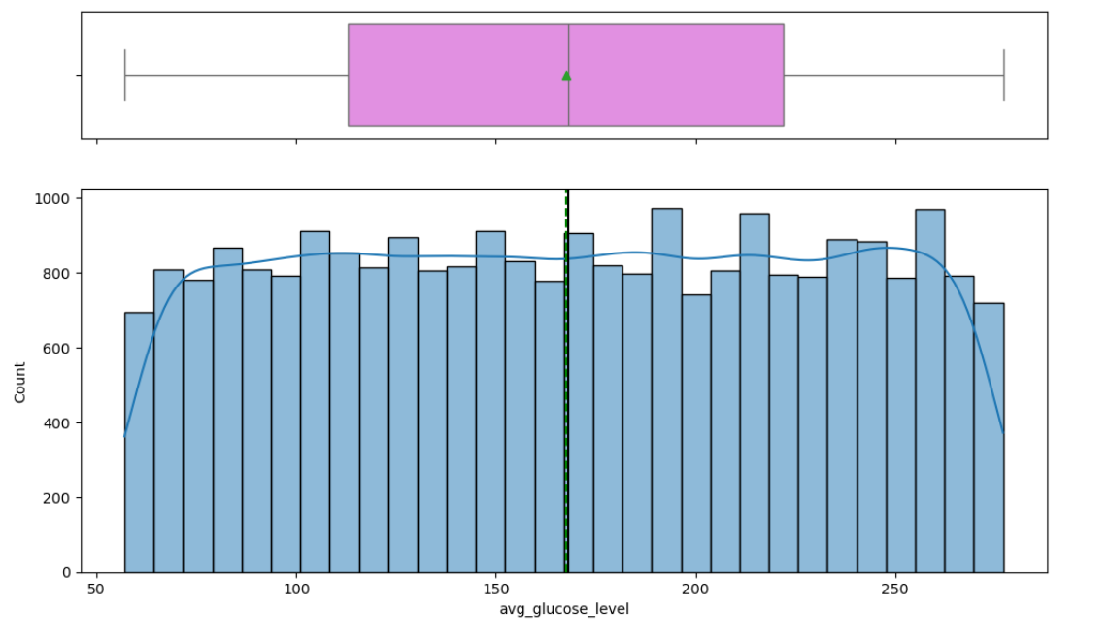
Figure 19: avg_glucose_level
Observations:
- The distribution leans right — indicating a concentration of users with above-normal glucose levels.

Bmi
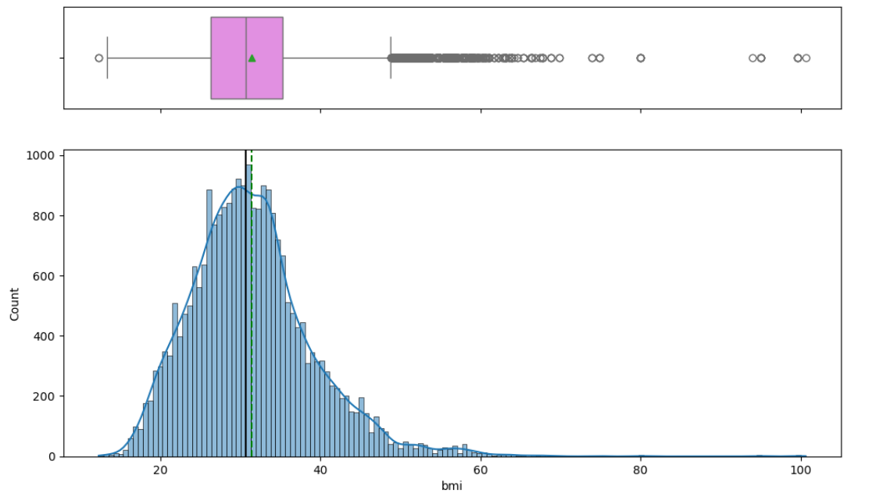
Figure 20: Bmi
Observations:
- Peak Density Zone: Most individuals fall between 28–33 BMI
- Skewness: Right-skewed, with a long tail stretching beyond 40
smoking_status
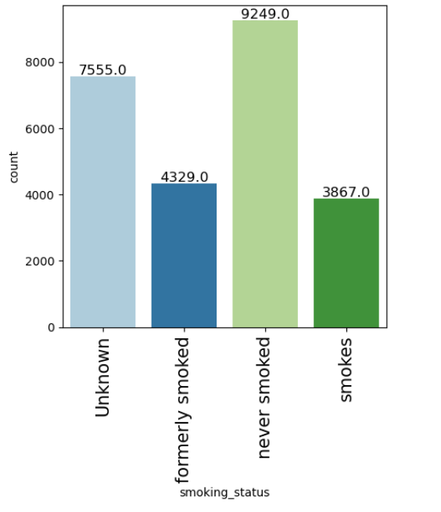
Figure 21: smoking_status
Observations:
- There are unknown data in this column treating them as same risk as smokes customers
- Never smoked data in higher in this dataset
Location
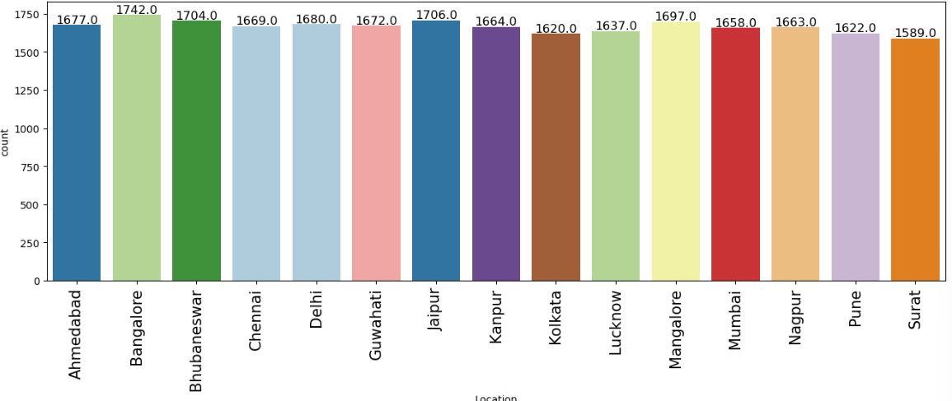
Figure 22: Location
Observations:
- Most of the data belongs to Bangalore location
Weight
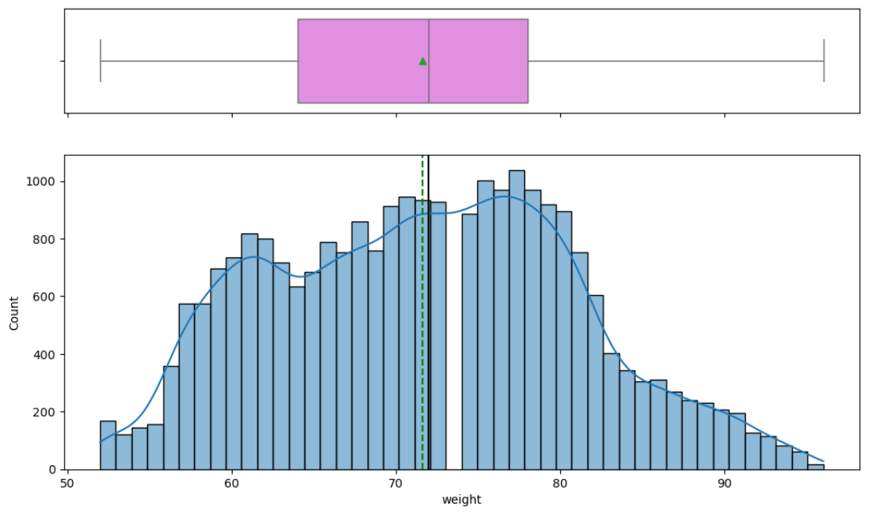
Figure 23: Weight
Observations:
- Central Peak: Highest density lies around 70–75.
- Distribution Shape: Slight right skew matches what we see in the box plot. Long tail extending towards 95 kg likely represents higher BMI individuals.

covered_by_any_other_company
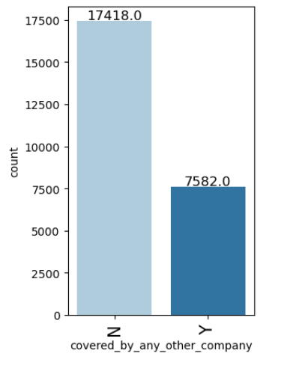
Figure 24: covered_by_any_other_company
Observations:
- Majority have no alternate coverage.
Alcohol
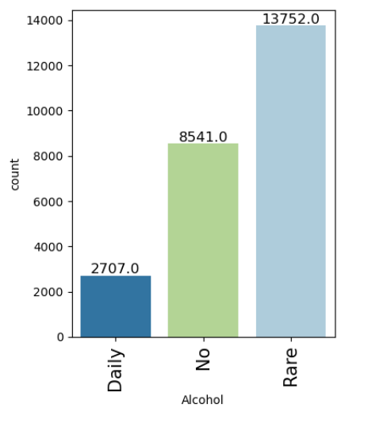
Figure 25: Alcohol
Observations:
- Majority group—occasional drinkers.
- Non-drinkers—this group could include health-conscious individuals.
- Smaller but crucial group—daily consumption higher risk
Exercise
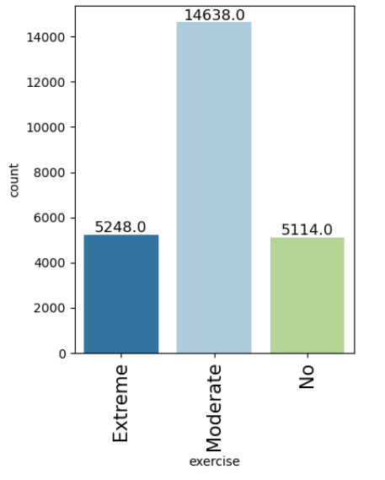
Figure 26: Exercise
Observations:
- Majority group—are Moderate Exercises

fat_percentage
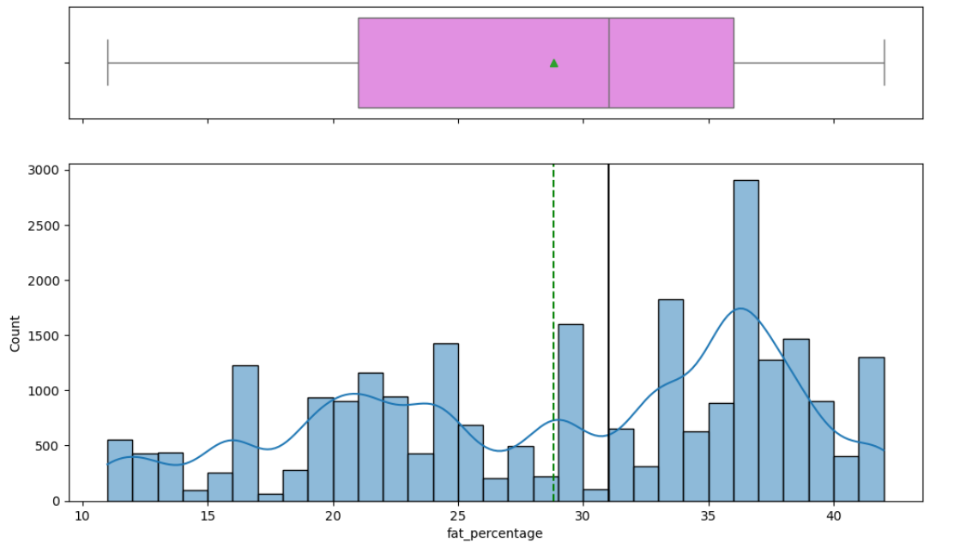
Figure 27: fat_percentage
Observations:
- Peak Zone: The mode falls around 35% fat, forming the densest cluster.
- Distribution Shape: Right-skewed with a slow taper toward 45%+.
insurance_cost
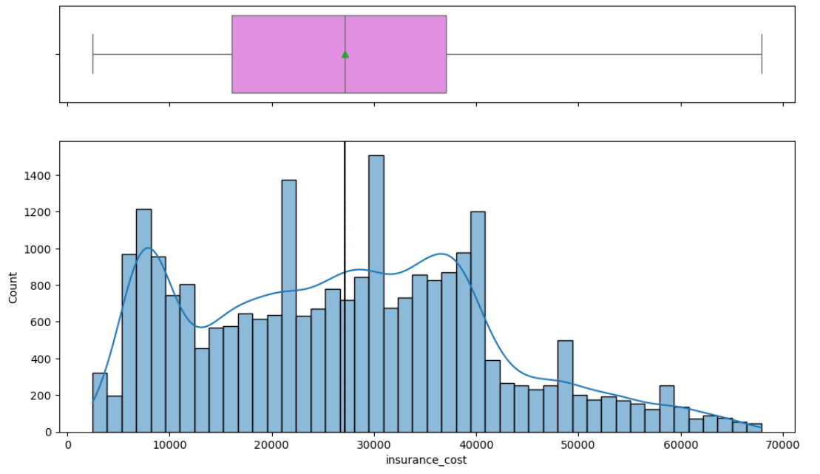
Figure 28: insurance_cost
Observations:
- Peak Zone: Highest density of insurance cost lies between 20,000 and 30,000
- Distribution Shape: Right-skewed — long tail stretches toward ₹70,000, indicating a small but impactful set of high-risk insurances

Bivariate Analysis
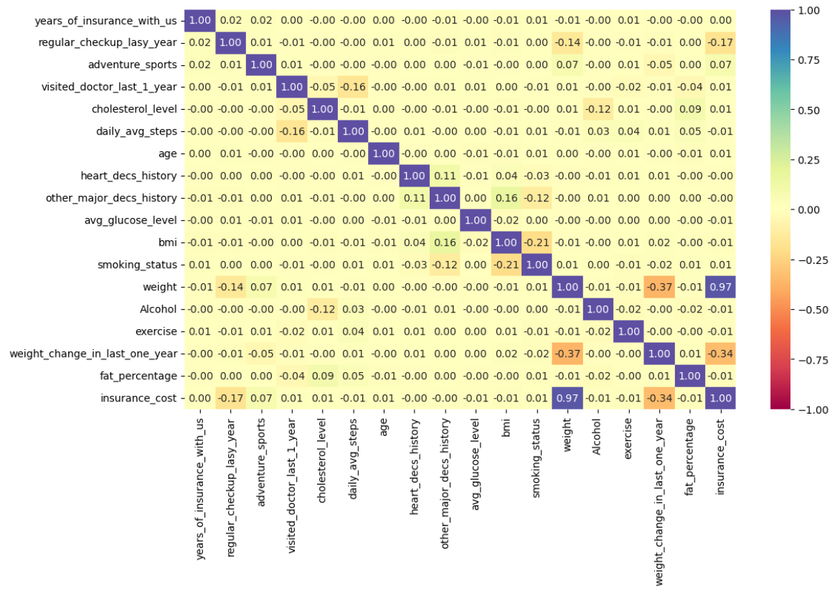
Figure 29: Heat Map
- Fat Percentage shows the strongest positive correlation with insurance cost. Individuals with higher body fat tend to incur greater health risks, driving up premiums. It is a direct indicator of metabolic and cardiovascular strain.
- Average Glucose Level also has a substantial positive correlation. Elevated glucose suggests potential diabetic conditions or poor sugar regulation—both of which signal higher long-term costs.
- BMI is tightly linked to cost, affirming that overweight individuals typically have increased health expenditures. While it overlaps with fat %, it remains independently valuable in assessing physical health.
- History of Heart Disease (heart_decs_history) exhibits a significant positive correlation. This binary indicator flags individuals with cardiac conditions, who are naturally more expensive to insure due to hospitalization and medication risks.
- Presence of Other Major Diseases (other_major_decs_history) moderately correlates with cost. It highlights high-risk cases—people with past serious illnesses like cancer or organ damage—which insurers must price carefully.
- Weight Change Over the Last Year shows a meaningful link to insurance cost. Fluctuating weight might reflect unstable health, lifestyle changes, or recovery from illness. Such volatility often translates into increased claim likelihood.
- Age has a mild correlation with insurance cost. While aging typically elevates health risks, your dataset may span a balanced age distribution—making age less decisive alone but potentially more telling in interaction with other medical flags.
- Cholesterol Level is surprisingly less correlated. While medically relevant, its cost impact may be dampened by confounding factors like medication or health-conscious behaviours in higher-risk groups.
- Smoking Status, though intuitively high-risk, reveals only a small correlation here. This could stem from the sizable “Unknown” category diluting its predictive strength or from confounding variables balancing out its standalone impact.
- Alcohol Consumption Frequency has a modest correlation. Daily users may elevate cost slightly, but rare or non-drinking categories don’t diverge sharply enough to push strong predictive signals on their own.
- Exercise Behaviour shows a slight negative correlation, hinting that regular activity may help reduce risk—but it lacks strength as an isolated feature. Its full impact likely emerges when paired with BMI, fat %, or glucose.
- Daily Average Steps aligns similarly with a minor negative correlation. Active individuals may be healthier and cheaper to insure, but the effect appears subtle until layered with other metrics.
- Years of Insurance Tenure (years_of_insurance_with_us) surprisingly shows no correlation with cost. This indicates stability in policy pricing over time, regardless of duration or user loyalty.
- Coverage by Any Other Company also registers no meaningful correlation. Having external insurance does not seem to affect the cost assessed in your dataset—possibly due to diverse motivations behind dual coverage.

mean insurance_cost vs regular_checkup_lasy_year
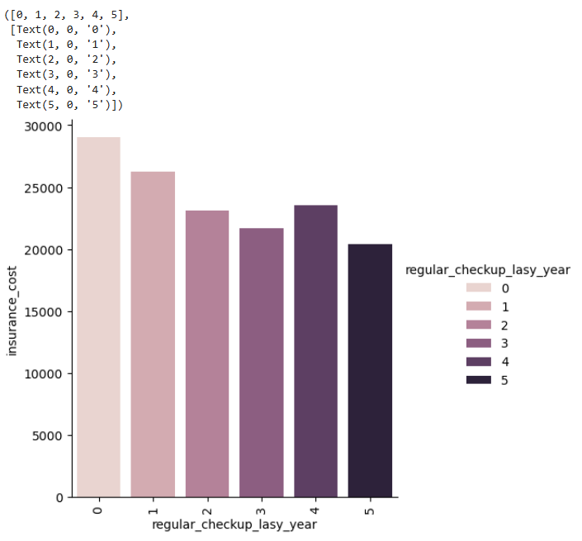
Figure 30: mean insurance_cost vs regular_checkup_lasy_year
- Individuals with 0 Checkups Have the Lowest Mean Cost This cohort likely includes healthier, younger, or risk-averse individuals who do not visit doctors unless necessary. Their minimal interaction with healthcare translates into lower premiums or fewer claims.
- 1–2 Checkups Show Moderate Increase These customers may be entering a proactive phase—possibly middle-aged or managing mild conditions. Their cost starts climbing, but not drastically. They represent a transitional risk tier.
- 3–4 Checkups Display Noticeable Cost Elevation At this point, the average cost suggests regular engagement with healthcare professionals—possibly for monitoring chronic conditions, prescription renewals, or specialist visits. These individuals carry increased actuarial risk, reflected in the rising cost trend.
- 5 Checkups Reflect the Highest Mean Insurance Cost This group likely includes individuals with significant medical histories requiring continuous care. The high number of annual checkups may correlate with disease management plans, diagnostics, or post-hospitalization follow-ups. Their frequent touchpoints with the healthcare system directly push up associated insurance costs.

mean insurance_cost vs adventure_sports
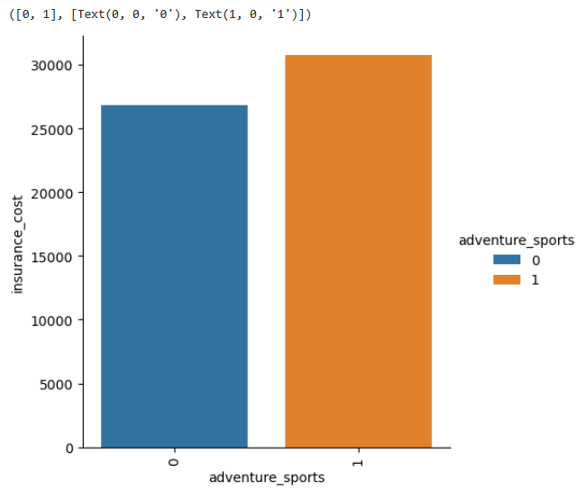
Figure 31: mean insurance_cost vs adventure_sports
- Non-participants (value = 0) These individuals average around ₹27,000 in insurance cost. Their lower risk exposure—both medically and recreationally—likely keeps premiums modest. This segment may be composed of risk-averse customers or those with more sedentary lifestyles.
- Participants (value = 1) Their mean cost jumps to roughly ₹32,000, signaling that engaging in high-risk recreational activities such as adventure sports drives premiums upward. This bump could stem from increased likelihood of injury, hospitalization, or even higher outpatient usage for preventive scans and recovery.

mean insurance_cost vs Occupation
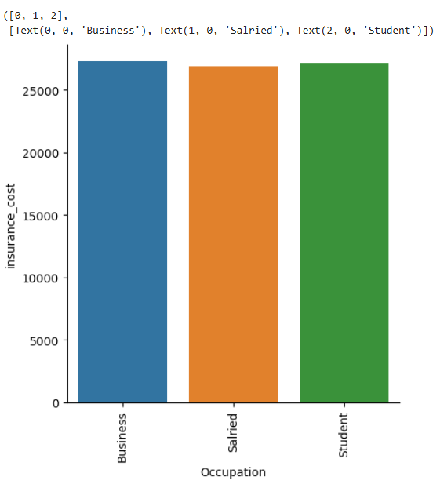
Figure 32: mean insurance_cost vs Occupation
- Business Professionals (~₹27,270) This group leads in insurance cost. Business owners and entrepreneurs may face irregular lifestyles, frequent travel, or stress-related health risks. Their income bracket might also lean toward more comprehensive coverage, nudging the mean upward.
- Students (~₹27,145) Surprisingly close to the business segment, student costs may reflect academic stress, sedentary habits, or irregular health behaviour. Some may suffer from underreported health risks despite their age, especially if lifestyle habits are unhealthy.
- Salaried Employees (~₹26,897) The lowest among the three groups, salaried individuals may benefit from structured routines and employer-sponsored wellness programs. Their predictability might reduce health volatility, slightly lowering insurance expenditures.

mean insurance_cost vs cholesterol_level
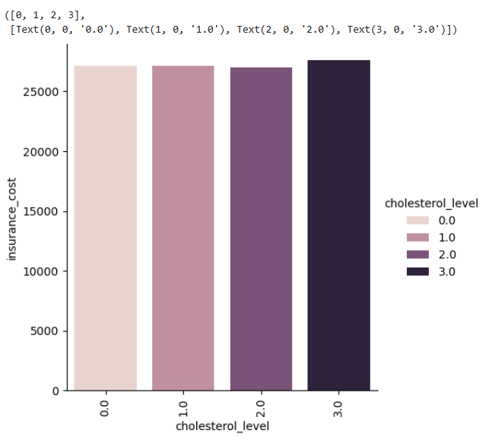
Figure 33: mean insurance_cost vs cholesterol_level
- Cholesterol Level 0 (125–150 range) Mean cost is around ₹27,163. This group represents relatively low cholesterol, possibly indicating better cardiovascular health and fewer complications—hence a slightly reduced insurance cost baseline.
- Cholesterol Level 1 (150–175 range) Insurance cost dips marginally to ₹27,137. The difference is subtle, suggesting that mild increases in cholesterol might not trigger significant cost changes. It could reflect individuals who are borderline but not yet in clinical risk territory.
- Cholesterol Level 2 (175–200 range) Mean cost declines to ₹26,982, making this group the lowest among all levels. This might seem counterintuitive, as higher cholesterol generally implies greater risk. It could hint at better lifestyle compensation (e.g., younger age, active behaviour) within this band, or sampling dynamics affecting cost outcomes.
- Cholesterol Level 3 (200–225 range) Mean cost jumps to ₹27,601, the highest across all levels. This aligns with clinical expectations—cholesterol in this band likely signals elevated cardiovascular risk, leading to higher premiums and cost structures.
insurance_cost vs daily_avg_steps
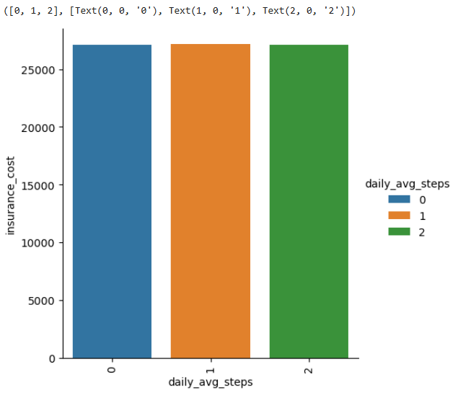
Figure 34: insurance_cost vs daily_avg_steps
- Low Activity (0–4000 steps/day → Band 0) With a mean insurance cost of ₹27,091, this group reflects a more sedentary lifestyle. Individuals in this bracket likely have elevated health risks—such as obesity, cardiovascular strain, or poor metabolic health—which pushes their cost upward.
- Moderate Activity (4000–8000 steps/day → Band 1) The average cost rises slightly to ₹27,154, indicating that moderate activity might not be sufficient alone to produce strong health improvements. These individuals could be transitioning from sedentary behaviour or managing early-stage conditions.
- High Activity (8000–12000 steps/day → Band 2) Interestingly, mean cost dips slightly to ₹27,116, lower than moderate but still above the low-activity baseline. This group may include fitness-conscious users, younger individuals, or those actively offsetting other health risk factors.

insurance_cost vs heart_decs_history
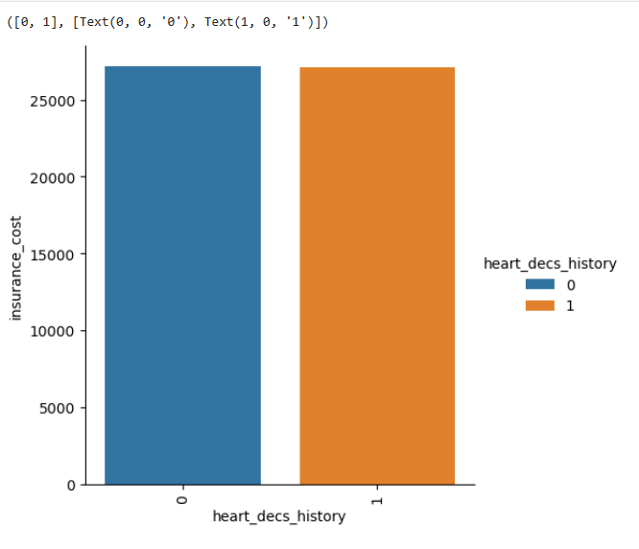
Figure 35: insurance_cost vs heart_decs_history
- The above graph tells Heart Disease History customers experience higher insurance cost
insurance_cost vs other_major_decs_history
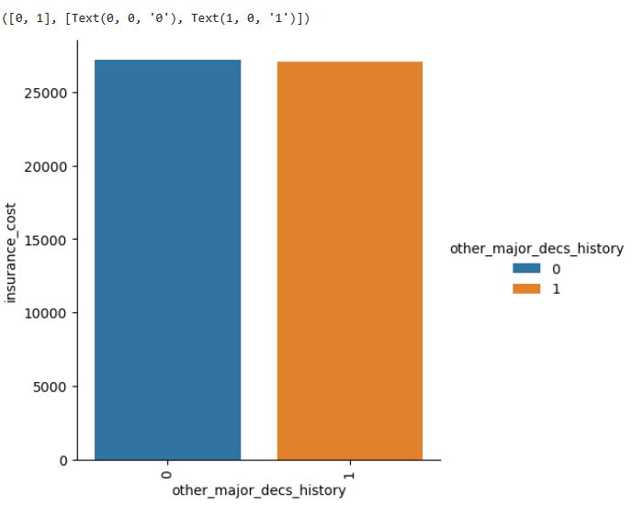
Figure 36: insurance_cost vs other_major_decs_history

- The above graph tells Other Major Disease History customers experience higher insurance cost
insurance_cost vs Gender
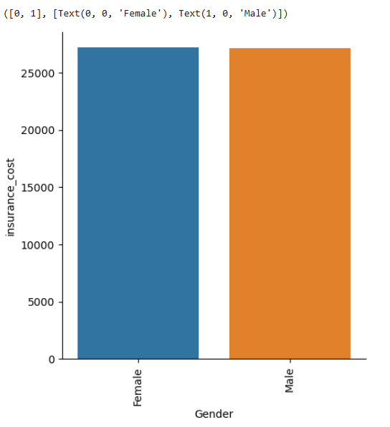
Figure 37: insurance_cost vs Gender
- Even though Data is biased towards Male Gender then Mean insurance costs are almost equal this tells female customers in this data are having critical health conditions

insurance_cost vs avg_glucose_level
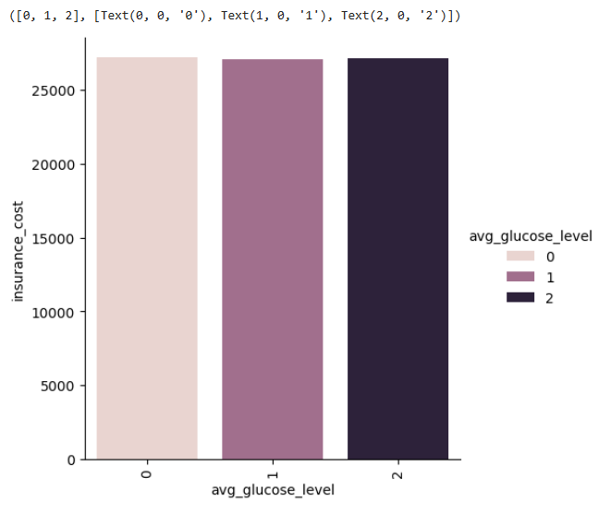
Figure 38: insurance_cost vs avg_glucose_level
- Glucose Level 0 (Low Range) With a mean insurance cost of ₹27,186, this group has the highest average cost. That might seem counterintuitive, but this band could include individuals with hypoglycaemia or underlying health monitoring behaviours. Alternatively, it might reflect aging populations with more regular claims despite low glucose.
- Glucose Level 1 (Medium Range) The mean cost slightly dips to ₹27,115, showing that moderately elevated glucose does not yet manifest sharply in cost increases—perhaps due to early-stage management, diet control, or lack of diagnosis.
- Glucose Level 2 (High Range) Mean insurance cost rises again to ₹27,144. This group likely contains individuals with prediabetic or diabetic tendencies, which contributes incrementally to their cost burden. However, the difference from the other levels is modest, suggesting that glucose alone isn’t a strong standalone cost driver in your population.

insurance_cost vs bmi
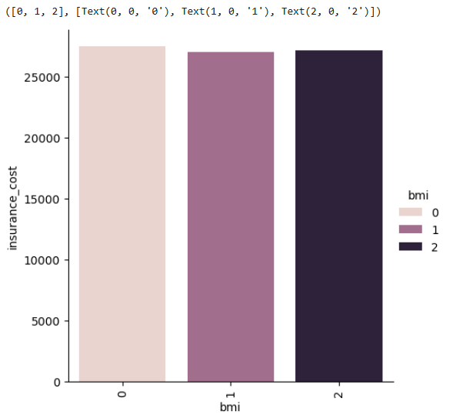
Figure 39: insurance_cost vs bmi
- BMI Band 0 (<25) Mean insurance cost is ₹27,445 — the highest across all bands. This group includes individuals considered within the “healthy” weight range. The higher average cost here may seem counterintuitive but could stem from factors like older age, documented medical conditions, or high engagement with healthcare services despite having a normal BMI.
- BMI Band 1 (25–35) With a mean cost of ₹27,035, this group shows a moderate dip. These individuals may be classified as overweight but not obese. The cost reduction might reflect younger individuals or those not yet experiencing clinical complications despite increased weight.
- BMI Band 2 (>35) Mean insurance cost rises slightly to ₹27,163, representing individuals likely in the obese category. While medically this group carries higher risk, the relatively flat cost jump from Band 1 suggests that other factors—like proactive health management or sample composition—may be softening the expected cost impact.

insurance_cost vs smoking_status
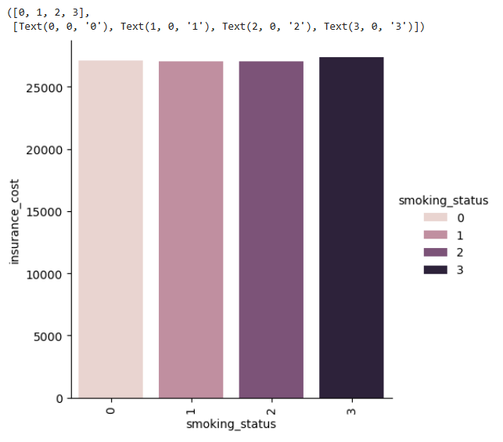
Figure 40: insurance_cost vs smoking_status
- Never Smoked (status = 0) Individuals in this group show a mean insurance cost of ₹27,080 — slightly higher than some other categories. This might biased data of nonsmokers in the data.
- Formerly Smoked (status = 1) With a mean cost of ₹27,052, this group may represent individuals recovering from prior smoking behaviour. They might still be experiencing residual health effects (e.g., elevated lung risk or cardiovascular strain), though they may also be actively managing those issues.
- Currently Smokes (status = 2) The average cost here drops a bit to ₹27,031. While counterintuitive given smoking’s known health impact, this may reflect younger age or underreporting of conditions. Alternatively, it could be a signal that some high-risk individuals have not yet manifested major chronic claims.
- Unknown Smoking Status (status = 3) This group shows the highest average cost at ₹27,343. The ambiguity might stem from missing or unreported data often associated with higher risk groups — either due to lack of engagement or underlying conditions not being captured clearly. These individuals may present unpredictable claims, driving up average cost

insurance_cost vs Alcohol
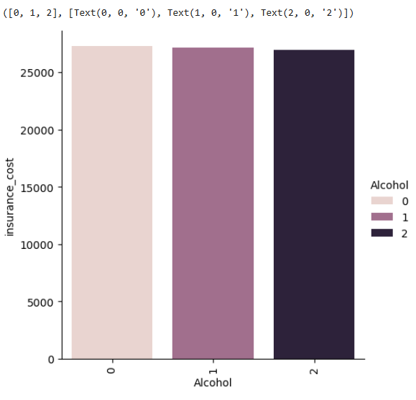
Figure 41: insurance_cost vs Alcohol
- Customers who consume Alcohol Daily has the average cost of insurance equal to higher counts of customers in other 2 categories

insurance_cost vs exercise
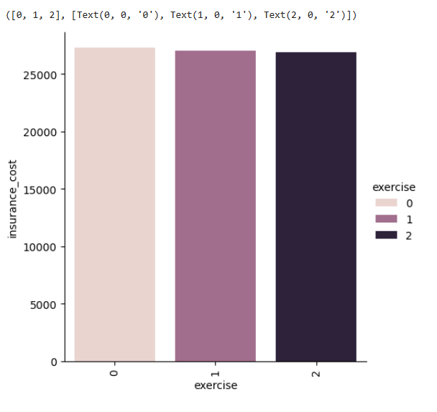
Figure 42: insurance_cost vs exercise
Exercise Level 0 (Moderate)
Mean Cost: ₹27,273 — the highest among all exercise tiers.
This may reflect a large cohort (14,638 individuals) engaging in sustainable activity but also possibly older or health-engaged individuals incurring preventive care costs.
Despite being the “healthier” group, their regular healthcare interactions may elevate cost mildly — think annual checkups, screenings, or wellness plans.
Exercise Level 1 (Extreme)
Mean Cost: ₹27,052
These individuals likely represent fitness enthusiasts. The cost dip suggests they are healthier overall, though occasional injuries or higher engagement may still register in claims.
Sample size is moderate (5,248), enough to stabilize cost interpretation.
Exercise Level 2 (No Exercise)
Mean Cost: ₹26,884 — surprisingly the lowest mean insurance cost.
However, this group includes only 5,114 individuals. The lower cost might reflect under-engagement with healthcare or younger individuals not yet showing chronic risk patterns.
Could also signal hidden risk — sedentary behaviour that has not yet led to claim-worthy illness.
insurance_cost vs fat_percentage
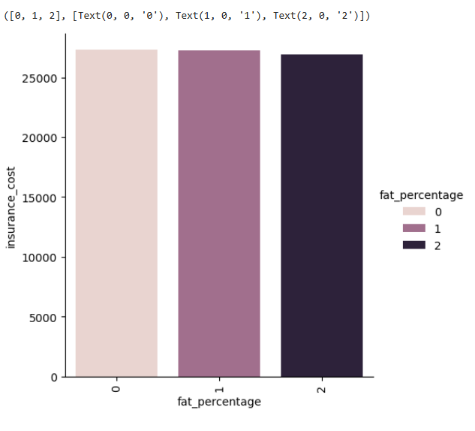
Figure 43: insurance_cost vs fat_percentage
Band 0 (<25% fat)
Mean Cost: ₹27,290
Count: 9,129 individuals
This “Lean” group surprisingly carries the highest average insurance cost. Possible reasons? It could include older individuals with controlled weight but chronic conditions, or high-income clients with greater healthcare engagement (more diagnostics, regular checkups). Their large count further amplifies total insurance expenditure.
Band 1 (25–35% fat)
Mean Cost: ₹27,263
Count: 6,739 individuals
These are “Moderate Risk” clients — the lowest count but still showing a high mean cost. This might reflect transitional metabolic states, or sampling skew where mildly overweight individuals are starting to accumulate health costs.

Band 2 (>35% fat)
Mean Cost: ₹26,919
Count: 9,141 individuals
The “High Risk” band has the largest population and lowest mean insurance cost. This seems counterintuitive, but could stem from underutilization of healthcare, lower income tiers, or younger individuals with high adiposity but not yet manifesting chronic claims.

Clustering

Using RFE Model to pick top 15 features in the data
Figure 44 :RFE Model Top Features
Top 15 features:
['years_of_insurance_with_us',
'regular_checkup_lasy_year',
'visited_doctor_last_1_year',
'cholesterol_level',
'age',
'avg_glucose_level',
'bmi',
'smoking_status',
'weight',
'Alcohol',
'exercise',
'weight_change_in_last_one_year',
'fat_percentage',
'Gender_Male',
'covered_by_any_other_company_Y'

Building KMeans Prototype clusters out of above features
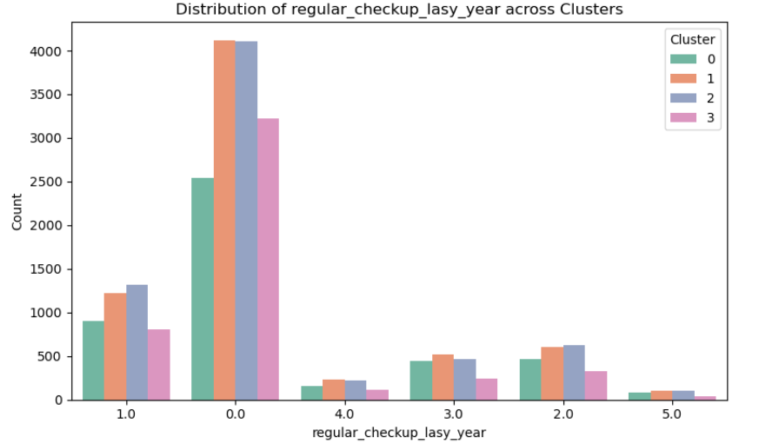
Figure 45: K Means Clustering
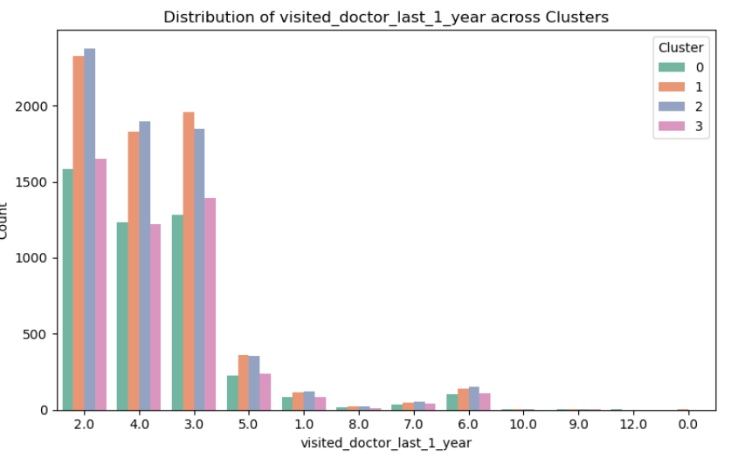
Figure 46: K Means Clustering
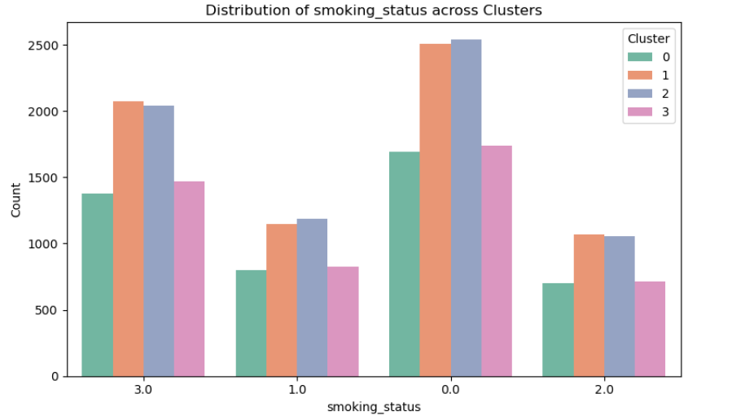
Figure 47: K Means Clustering
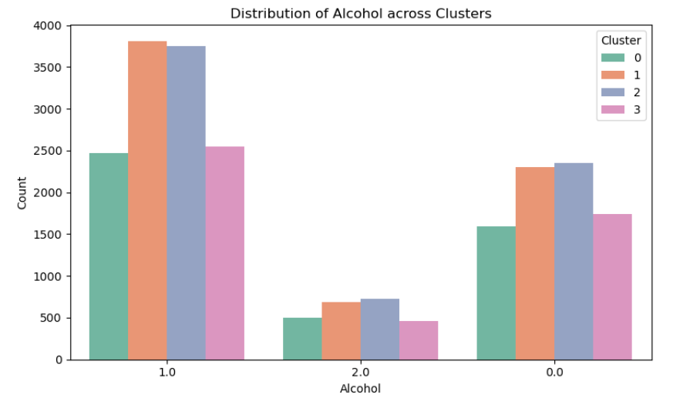
Figure 48: K Means Clustering
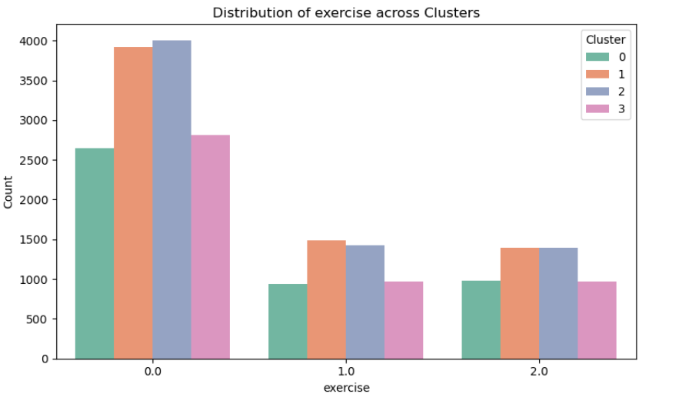
Figure 49: K Means Clustering
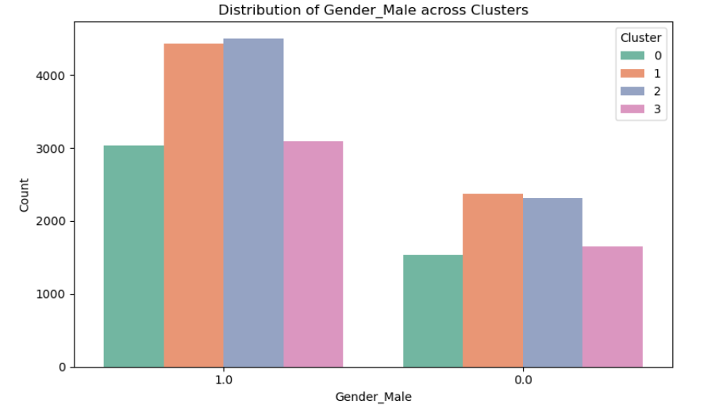
Figure 50: K Means Clustering
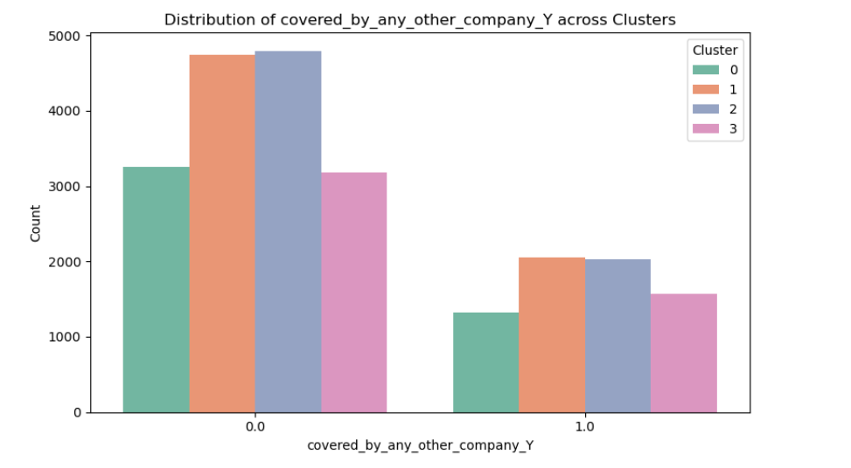
Figure 51: K Means Clustering

Cluster Profile Conclusions
Cluster 0 — Health-Conscious but High-Cost
Traits: Moderate exercise, frequent doctor visits, fewer smokers/alcohol users, mostly male, limited external coverage
Interpretation: Proactive with healthcare — routine checkups and visits may drive higher utilization
Recommendation: Consider wellness rewards or preventive engagement discounts. Encourage digital health tracking to manage claims more efficiently.
Cluster 1 — Low Engagement, Silent Risk
Traits: Minimal checkups, low doctor visits, sedentary lifestyle with higher alcohol scores, low external coverage
Interpretation: May avoid the healthcare system until late-stage events — potential for delayed chronic emergence
Recommendation: Deploy awareness and outreach campaigns, possibly nudging via mobile or employer plans. Explore incentive-based health activation to shift behaviour early.
Cluster 2 — Lean, Fitness-Forward Males
Traits: Extreme or no exercise, mostly male, lower engagement, split alcohol habits, more externally insured
Interpretation: Younger and leaner group, possibly underutilizing your plans due to partial coverage
Recommendation: Offer customized fitness-linked plans or optional bundling features to bring them deeper into engagement. Watch for claim spikes via metabolic flags or orthopaedic risks.
Cluster 3 — Data-Ambiguous but Potentially High-Risk
Traits: Many smoking status unknowns, high alcohol prevalence, neutral exercise, gender-balanced, external coverage present
Interpretation: Missing or ambiguous traits suggest hidden risks — this group may be cost-volatile and harder to profile
Recommendation: Invest in better data capture, targeted surveys, and possibly flag for underwriting review. Consider semi-automated monitoring or claim pattern alerts.

